Case Western Reserve University

Department of Chemical Engineering

AW Smith Building

2128 Adelbert Road

Cleveland OH, 44106

|  |
| --- |
| High Efficiency Heat Exchanger Network |
| Sean Markwell, Matthew Napfel, Edward Revers, Philip Young  November 17, 2011 |
| *The Heat Exchanger Network Design Group will conduct an experiment to determine which configuration of heat exchangers and cooling water will produce streams at 55C and 40C at the highest efficiency. By experimentally determining the U value of each heat exchanger, we can set up a network of heat exchangers and compare its efficiency to the simulated efficiency of our ChemCAD model. In the future this data can be used to further optimize the system and use as little cold water as possible.* |

**Primary Safety Concerns**

The team’s main concerns lie with the use of hot steam and water. Guidelines are provided for proper attire throughout the procedure.

Laboratory Attire

* Lab Coat – protection against possible 1st, 2nd, and 3rd degree burns
* Safety Goggles – protection against hot steam or water leaks
* Lab Safety Leather Gloves – protection against possible 1st, 2nd, and 3rd degree burns
* Closed-toed shoes and long pants are required
* Contact lenses must be removed, and long hair is to be tied back
* Be sure to remove all jewelry (watches, necklaces, etc.). Should these personal items come in contact with hot pipes they may heat up and burn your arm or possibly melt from the heat.
* Do not wear loose clothing and neckties, and button up lab coats to ensure safety

Hazards of steam and hot water burns

* Proper techniques must be followed when working with steam and hot water.
  + Wear personal protective equipment including lab coat, safety goggles, and protective leather gloves which should be safe for even the highest temperature of the pipes, 150 degrees Celsius, or 302 degrees Fahrenheit.
* Contact with skin may cause serious burns

In the event of:

* 1st degree or small 2nd degree burns – Identify the burn **First-degree burn:** This minor burn affects only the outer layer of the skin (epidermis). It causes redness and pain and usually resolves with first-aid measures within several days to a week. **Second-degree burn:** These burns affect both the epidermis and the second layer of skin (dermis), causing redness, pain and swelling. A second-degree burn often looks wet or moist. Blisters may develop and pain can be severe. Deep second-degree burns can cause scarring.
  + Cool the burn. Hold the burned area under cool (not cold) running water for 10 or 15 minutes or until the pain subsides. If this is impractical, immerse the burn in cool water or cool it with cold compresses. Cooling the burn reduces swelling by conducting heat away from the skin. Don't put ice on the burn.
  + Cover the burn with a sterile gauze bandage. Don't use fluffy cotton, or other material that may get lint in the wound. Wrap the gauze loosely to avoid putting pressure on burned skin. Bandaging keeps air off the burn, reduces pain, and protects blistered skin.
  + Take an over-the-counter pain reliever. These include aspirin, ibuprofen (Advil, Motrin, others), naproxen (Aleve) or acetaminophen (Tylenol, others).
* Large 2nd degree and 3rd degree burns – Identify the burn: **Third-degree burn.** Burns that involve the epidermis and the dermis and reach the tissue underneath them (subcutaneous tissue) are called third-degree burns. The skin may appear stiff, waxy white, leathery or tan. Third-degree burns can destroy nerves, causing numbness.
  + For major burns, call the Case Health Services Emergency number, 216-368-2450. Until an emergency unit arrives, follow these steps:
  + Don't remove burned clothing. However, do make sure the victim is no longer in contact with hot materials or exposed to heat or steam.
  + Don't immerse large severe burns in cold water. Doing so could cause a drop in body temperature (hypothermia) and deterioration of blood pressure and circulation (shock).
  + Check for signs of circulation (breathing, coughing or movement). If there is no breathing or other sign of circulation, begin CPR.
  + Elevate the burned body part or parts. Raise above heart level, when possible.
  + Cover the area of the burn. Use a cool, moist, sterile bandage; clean, moist cloth; or moist towels.
  + Source: <http://www.mayoclinic.com/health/first-aid-burns/FA00022>
* Fire – Initiate emergency shutdown plan for reactors, evacuate area, trigger closest fire alarm
  + If a person’s clothing ignites – Use fire blanket near main laboratory entrance; stop drop, and roll
* Equipment malfunction – Follow designated emergency shutdown plan described below

Heat Exchanger Network Operation

* Ensure all tubing is firmly connected to avoid leaks and spills
* Avoid contact with hot pipes or heat exchangers from the source to disposal

Emergency Shutdown Procedure

* Turn off hot and cold water source valves
* Always begin by turning on the cold water source, then the steam source.
* Always end a run by turning off the steam source first, then the cold water source

**Experimental Procedure**

Before entering the laboratory, be sure to wear the appropriate attire and follow the guidelines set by the safety concerns stated above. Familiarize the team with the apparatus, sketched in the Appendix. Test the functionality of all equipment by toggling the on/off switches. Remember to wear gloves at all times when near the heat exchanger apparatus.

Experimental Determination of U for each Heat Exchanger

1. Philip Young will be assigned to apparatus setup and tube fitting
   1. Ensure that all rubber tubes and hoses are securely fastened before turning on steam and cold water valves.
   2. Connect hot inlet stream(s) to the chosen heat exchanger(s) and the hot exit stream to a manual control valve to control the flow rate at precise values.
   3. Controlling the flow at the outlet of the heat exchanger gives the heat exchanger more time to transfer heat and ensures that there is a strong steady flow through both sides of the exchanger.
   4. Connect cold inlet stream(s) to the chosen heat exchanger(s) and the cold exit stream(s) to a manual control valve to control the flow rate at precise values
   5. Make all connections before turning on the steam or cold water sources.
2. Matt Napfel will be assigned to Excel file calculation
   1. This involves calculation of heat Q, overall heat transfer coefficient U, and the error through the system.
   2. This must be done on a personal laptop
3. The foreman (Sean Markwell) will be assigned to operate the ELVIS thermocouple and flow rate inputs (behind the computer)
   1. Ensure the ELVIS is turned on and connected to the computer.
4. Ed Revers and the foreman (Sean Markwell) will set up the LabVIEW VI
   1. The title of the LabVIEW program is NewHeatExchanger 2011 1.1
   2. This involves setting the correct file path and creating appropriate headers
   3. This also involves labeling each flow rate and thermocouple input from the ELVIS
5. Set up all National Instruments ELVIS inputs and label them appropriately in the LabVIEW VI to avoid confusion.
   1. This includes flow meter inputs from all valves used. These should not be altered much during the course of this experiment and can be tested by running cooling water through the valve and into the disposal.
   2. This also includes thermocouple inputs from the heat exchangers used. These inputs will change frequently during the first half of this experiment. To identify thermocouples set a heat exchanger up, connect the thermocouples from that heat exchanger to the ELVIS one by one and watch the LabVIEW NewHeatExchanger 2011 1.1 Virtual Interface front panel for a signal.
6. Set up plate and frame heat exchanger #1 for U calculation
   1. All heat exchangers will be run in counter-current configuration to achieve the highest efficiency possible. Counter-current provides the greatest efficiency because the temperature gradient across the length of the heat exchanger is higher. To achieve counter current flow in the
   2. Connect cooling water in tube to input A of the heat exchanger.
   3. Connect the cooling water out from output B of the heat exchanger to manual control valve input 4a and from valve output 4b and to the water disposal.
   4. Connect hot stream in tube to counter-current input Q of the heat exchanger
   5. Connect hot stream output V from the heat exchanger to manual control valve input 5a and from valve output 5b to the water disposal.
   6. Connect thermocouple inputs from A, B, Q, and V to the National Instruments ELVIS.
   7. Locate and label the inputs of each thermocouple in the LabVIEW VI.
   8. Ensure that flow rates and temperatures are measured at each stream input and output.
   9. Set flows of each valve to the conditions listed in the Experimental plan found in the appendix.
   10. Allow apparatus to run until steady state is reached in the heat exchanger
7. Once steady state has been reached, begin recording header and data with the LabView VI.
   1. Collect data from 3 runs at different flow rates listed in the Experiment Plan contained in the appendix. Three runs will be to judge the effect of viscosity on the heat transfer coefficient U. Trials at 3 flow rates will give a useful range of U values should the flowrates need to be adjusted in the second part of the experiment.
   2. Use collected data to calculate the U, F, and percent error of each heat exchanger.
   3. Input steady state data values into Excel spreadsheet to calculate the U and F (from Y and Z values and chart in the appendix.)
   4. At the end of the run, stop data collection and change the LabView VI header or file path to reflect new experimental conditions (new heat exchanger, heat exchanger type)
8. Repeat the experiment with each heat exchanger (Plate and Frame #2, Shell and Tube #1, Shell and Tube #2) designated from the apparatus diagram contained in the appendix.
9. Once the U for each heat exchanger has been calculated begin part 2 of the experiment

Heat Exchanger Network Experiment

1. Set up all network connections for heat exchanger network trial run (All inputs are given alphabetical labels in the Process Flow Diagram and Apparatus Diagram in the Appendix).
   1. Set up all tube connections and thermocouple inputs **before** turning on steam and water sources.
   2. Connect the hot water inlet tube from the input Q on the plate and frame heat exchanger (choose the plate and frame heat exchanger with the higher experimental U value from trials in part one of this experiment)
   3. Connect the hot water outlet tube to output V on the opposite side of the heat exchanger and to manual control valve input 4a and set it to 5.3 L/min. Then connect to the first T connector.
   4. Connect the yellow source cooling water tube to counter-current input A on the plate and frame heat exchanger.
   5. Connect the cooling water outlet tube from output B to manual control valve input 5a and set flow at 2.0 L/min. Connect output 5b to the disposal.
   6. Connect a tube from one side of the T connector to automated valve input 2a to control the flow rate at exactly 2.0 L/min. Connect valve output 2b to the disposal stream. This stream is our 55 C and 2.0 L/min product.
   7. Connect the last leg of the T connector to a tube which should then be connected to shell and tube heat exchanger #1 at input W
   8. Connect a tube from hot output X to hot input Y of shell and tube heat exchanger #2.
   9. Connect a new stream of cooling water from the yellow source tube to input C of shell and tube heat exchanger #1.
   10. Connect a tube from cold output D to cold input E of shell and tube heat exchanger #2. This is recycling our cooling water.
   11. Connect a tube from hot output Z to manual valve input 6a and set flow at 3.3 L/min. Connect valve output 6b to the waste disposal. This stream should be our 40 C and 3.3 L/min product.
   12. Connect a tube from cold output F to automated valve input 3a. Connect valve output 3b to the waste disposal.
2. Connect all necessary thermocouples to the LabVIEW VI
   1. Thermocouple readings are often duplicated in instances where the stream feeds straight from an output to the input of the next heat exchanger
   2. There are only 8 thermocouple inputs on the LabVIEW ELVIS
   3. Thermocouples are only needed at inputs/outputs A, C, E, F, Q, W, Y, and Z.
   4. Thermocouple inputs are not needed at B, D, V, and X
3. Once all thermocouples and tubes have been secured, run the network until it reaches steady state.
   1. Once steady state is reached, record the header and data in the LabVIEW VI
   2. Record all steady state flow rates and temperatures with a lab notebook and in a new Excel spreadsheet tab.
4. Once all data has been collected, begin shutdown procedure making sure to wear all proper safety equipment.
   1. Check to make sure all LabVIEW data has been collected
   2. Turn off cold water and steam at the source, starting with the steam.
   3. Carefully unfasten each tube and thermocouple and return them to their original position. (Thermocouples remain bundled behind the LabVIEW ELVIS, tubes and T connectors return to the plastic bin to the left of the apparatus.

**Example Calculations**

The equations used to calculate our Q heat values are given below:

$Q=mC_{p}ΔT$ (1)

$Q=UA∆T_{lm}$ (2)

In equation (1), m is the mass flow rate, Cp is the heat capacity of water, and ΔT is the temperature difference across the heat exchanger. In equation (2), U is the overall heat transfer coefficient, A is the area for the heat transfer and ΔTlm is the log-mean temperature-driving force for heat transfer. The ΔTlm is calculated using the equation below:

|  |  |  |
| --- | --- | --- |
|  | $$∆T_{lm}= \frac{∆T_{H_{in}H_{out}}-∆T_{C_{out}C_{in}}}{ln\frac{∆T_{H_{in}H_{out}}}{∆T_{C_{out}C_{in}}}}$$ | (3) |

The calculation of U, the overall heat transfer coefficient, is done by finding the Q value of the heat exchanger from equation (1) using experimentally determined temperatures and the known mass flow rate and heat capacity of water. We can plug this Q value back into equation (2), calculate the ΔTlm and use the known area values. Rearranging the equation this will give us the experimental U for a heat exchanger. This is shown in equation (4) below:

|  |  |  |
| --- | --- | --- |
|  | $$U=\frac{Q}{A∆T_{lm}}$$ | (4) |

It is important to consider the error in the heat (Q) calculation between the hot and cold streams. The heat lost by the hot stream should ideally be equivalent to the heat gained by the cold stream. The experimental system is non-ideal and has inherent inefficiencies, which makes the error calculation valuable for analysis. Error was calculated by equation (5) below:

|  |  |  |
| --- | --- | --- |
|  | $$\% error=\left(\frac{Q_{hot}- Q_{cold}}{\frac{Q_{hot}+ Q_{cold}}{2}}\right)×100$$ | (5) |

A dimensionless correction factor, F, must be applied to the heat calculations from equations (1) and (2) above to take into account multiple passes in the heat exchangers. Variables Y and Z are calculated and F is found from the graph included in the appendix. The equations for variables Y and Z are given below:

|  |  |  |
| --- | --- | --- |
|  | $$Y= \frac{T_{tube, out}-T_{tube, in}}{T_{shell, in}-T_{shell,out}}$$ | (6) |
|  | $$Z= \frac{T_{shell,in}-T_{shell,out}}{T_{tube,out}-T_{tube,in}}$$ | (7) |

**Appendix**

Please refer here for the apparatus sketch and Excel spreadsheets with calculations to find U, F, and percent error. Diagrams with labeled tube inputs and outputs, and thermocouple locations and inputs are also contained in this section.

**Heat Exchanger Network Experiment Plan**



**Counter-Current Exchange Diagram**

Figure 1

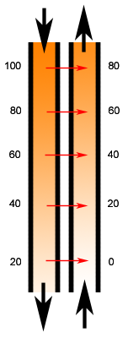

**Shell and Tube Heat Exchanger**

Figure 2

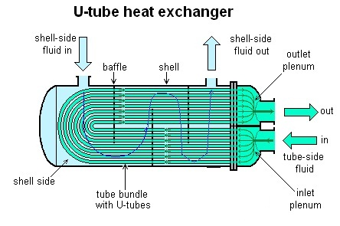

**Process Flow Diagram (from source to disposal)**

Figure 3



**Equipment Diagram**



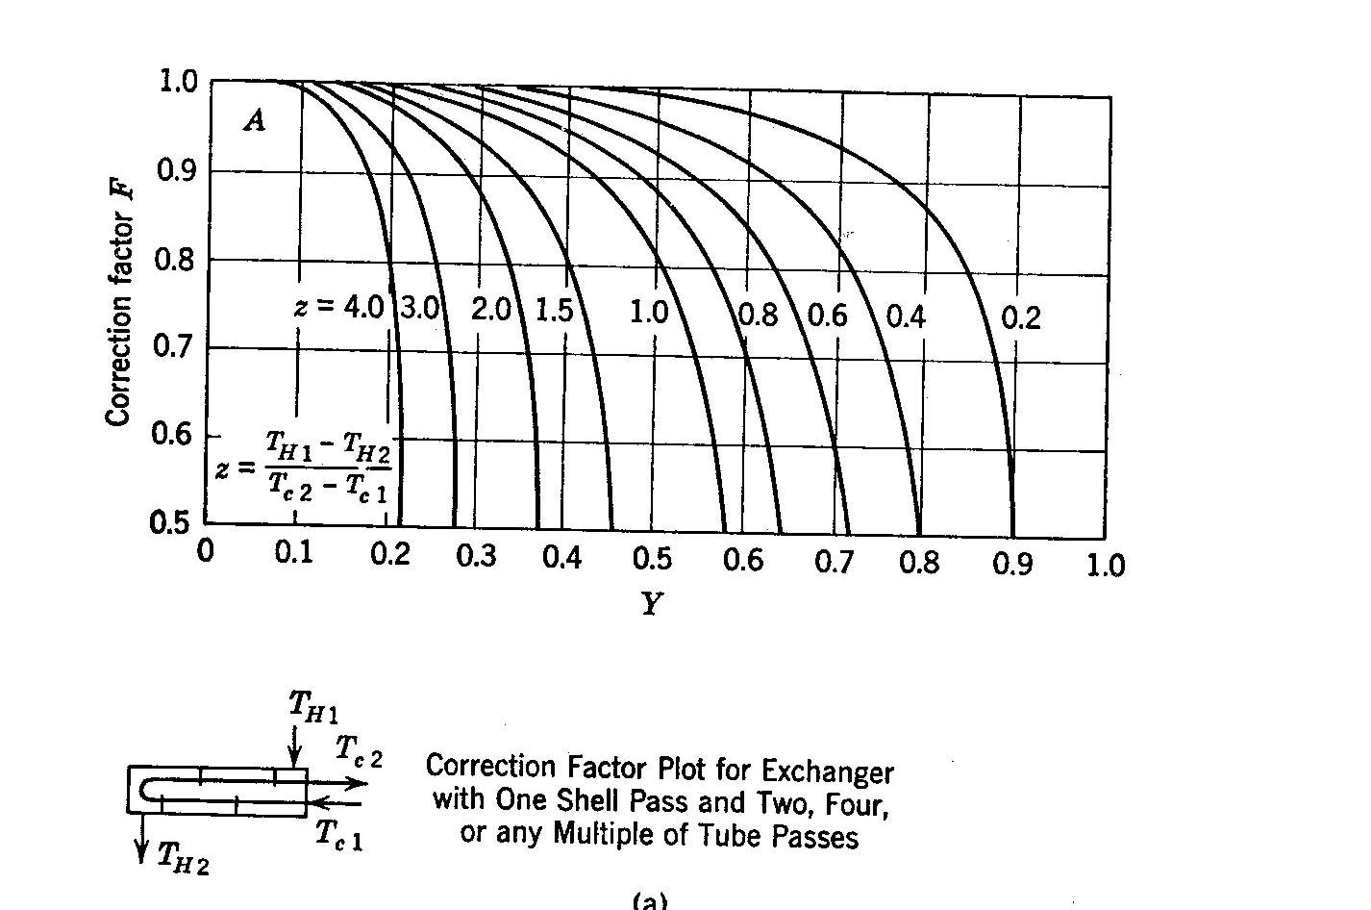**Correction Factor F**

**LabVIEW VI front panel**

